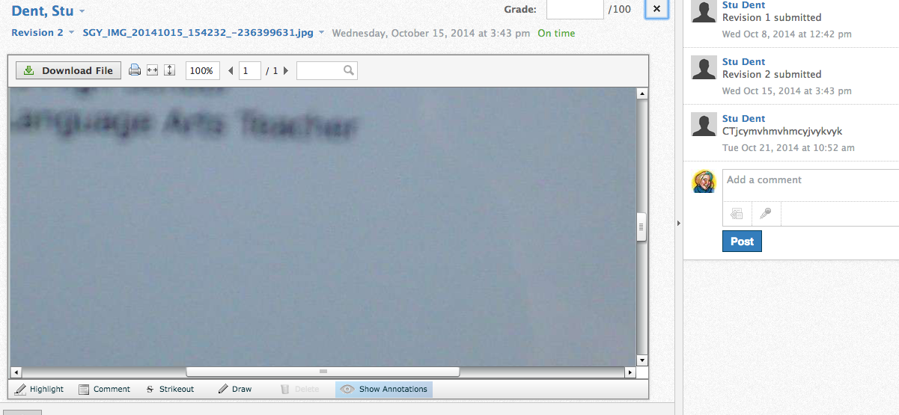

**Using the Audio/Video Features in Schoology – Do not use in Chrome**

In the comments section of the assignment box there is an audio button. When you click on it, you get the option of doing audio or video.

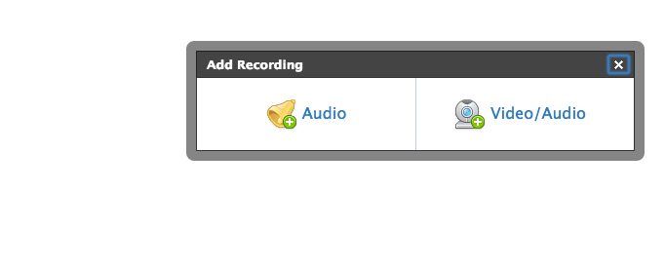

Click the one you want.

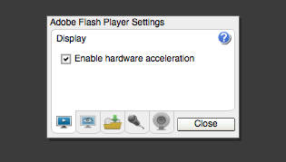

Make sure that you click **allow.** There are 4 tabs at the bottom, you want either the microphone or the webcamera.

Record yourself. When you are done, push the square and hit post.

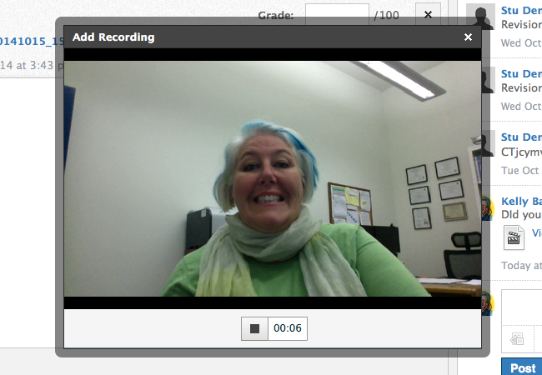

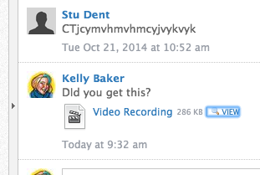

Students can view what you posted by clicking on “View” If they click on the “video recording” link, it will download it.